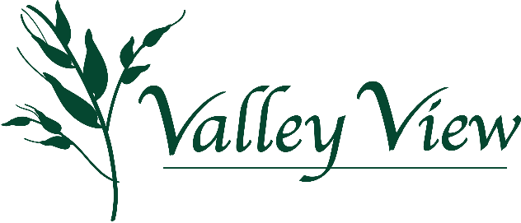
Toast to the View ~ Travel the Trails with us!
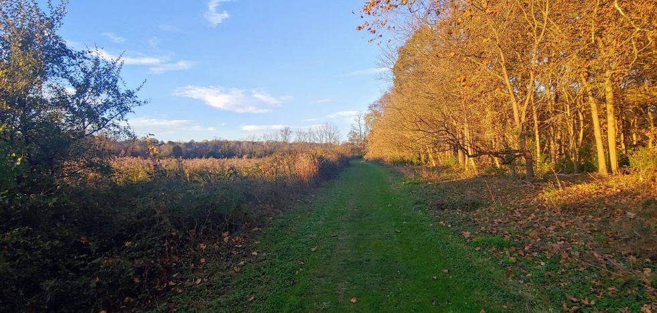
We are thrilled to be planning our annual event and look forward to an evening of good cheer traveling the trails, in the garden and by the barns with friends, neighbors and our community!
The Toast has become a fall tradition benefiting Valley View which would not be a success without our generous event sponsors. We look forward to sharing fun experiences and the story of Valley View.

Toast to the View
Saturday September 30st 5:00pm-8:00pm
Casual Fireside Attire for a Tour of the Trails and a Little Adventure
~ Joe Napoli’s Pizza Truck ~ Beverages ~ Music ~ Hayrides ~

We hope you will consider being a 2023 Toast to the View event sponsor in support of the
Valley View Nature Preserve.
Conserving Land...Preserving History...Sharing it with the Community
Help us celebrate a successful year, exciting plans for the future and enjoy a fun evening on the trails!

2023 Toast to the View Community Sponsor
Yes, we will support Valley View as a Toast to the View sponsor!

Company Name:______________________Contact person: _______________________

Contact phone #: ______________________Contact email: ________________________

Please indicate the sponsorship level you would like to contribute and return by August 18th:

790 Garfield Avenue Milford, Ohio 45150
www.valleyviewcampus.org to pay via credit card
Please call Vanessa Hannah (513) 218-1098 for further details or questions.

____$3,000.00 Toast Presenting Sponsor
Receive 6 complimentary tickets to the Toast. Also receive company name and logo prominently placed in promotional material, the event program, on all event signage, at all guest stations, on the Valley View website and mentioned in year-end donor correspondence.

____$2,000.00 Entertainment and Activities Sponsor
Receive 4 complimentary tickets to the Toast. Also receive company name and logo included in promotional material, the event program, event signage, prominently displayed by the musical performers and on the Valley View website.

____$1000.00 Food and Beverage Sponsor
Receive 2 complimentary tickets to the Toast. Also receive company name and logo in promotional material, the event program, prominently displayed at food and drink stations and on the Valley View website.

____$500.00 Golf Cart Sponsor
Receive company name listed on promotional material, the event program, prominently displayed in the golf carts and on the Valley View website.

____$250.00 Toes on the Trails Sponsor
Receive company name listed on promotional material, the event program and on the Valley View website.

